**Activity: Creating a QR code**

**Introduction**

You have discovered the significance of media elements in dashboard design and how to incorporate images, videos, text boxes, QR codes, and live-streaming data. In this exercise, you will apply your QR code knowledge in Microsoft Power BI service to generate codes for a dashboard tile and an entire report.

**Scenario**

Adventure Works has sales operations in global regions. Each region is managed by a country sales manager. Jamie, the CEO, wants to have a sales report that is easy to distribute and easy for all managers to access. In addition, she wants to target each country’s manager with sales data insights from the dashboard that are relevant to their own region. The most convenient way to accomplish both tasks is to generate QR codes for the **Adventure Works sales** report and the **sales by country** visual from the dashboard. Those QR codes can then be used as an e-mail attachment to distribute the report and dashboard. As an Adventure Works Power BI report designer, you can help Jamie achieve these goals.

Using an Adventure Works dashboard and report as examples, follow the steps in Power BI service to create QR codes.

**Generate a QR code for a dashboard tile**

**Step 1: Log into your Power BI service account and access My workspace**

1. Open **app.powerbi.com** in a browser and log into your account.
2. In Power BI service, open **My workspace** from the left navigation pane of the **Home** screen. **My workspace** lists all the assets you created or published from Power BI desktop. That includes datasets, reports, and dashboards.

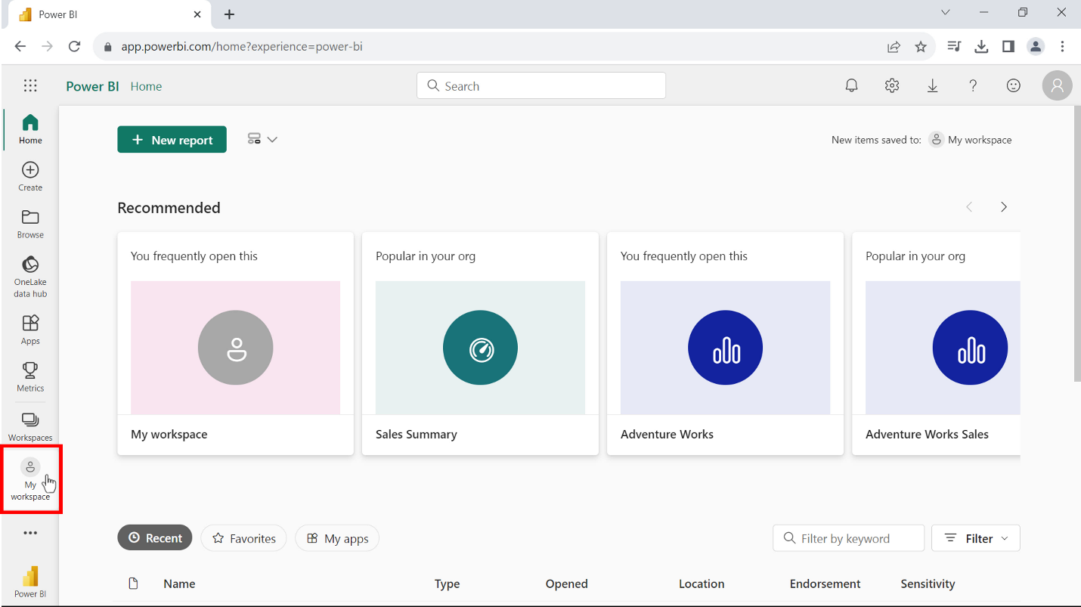

**Step 2: Open a dashboard and create a QR code**

1. From the list of assets in **My workspace,** open the *Sales Summary* dashboard. You created this dashboard in the previous lesson, *Optimizing a dashboard for mobile phones*.

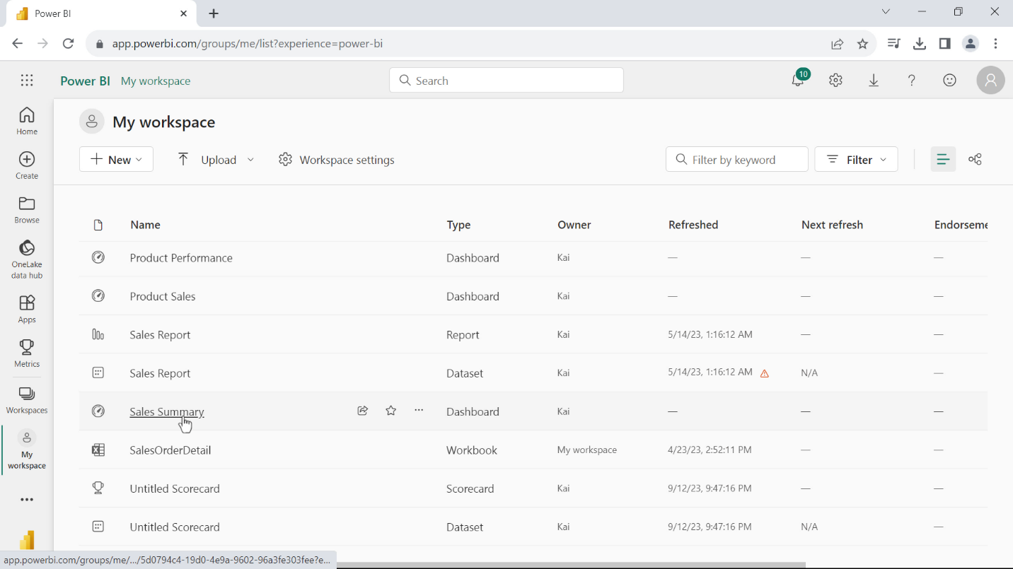

2. In the dashboard, locate the tile called **Sales by country** and select **More options**.

**Tip:** You can locate **More** **options** by selecting three dots on the top right corner of the tile.

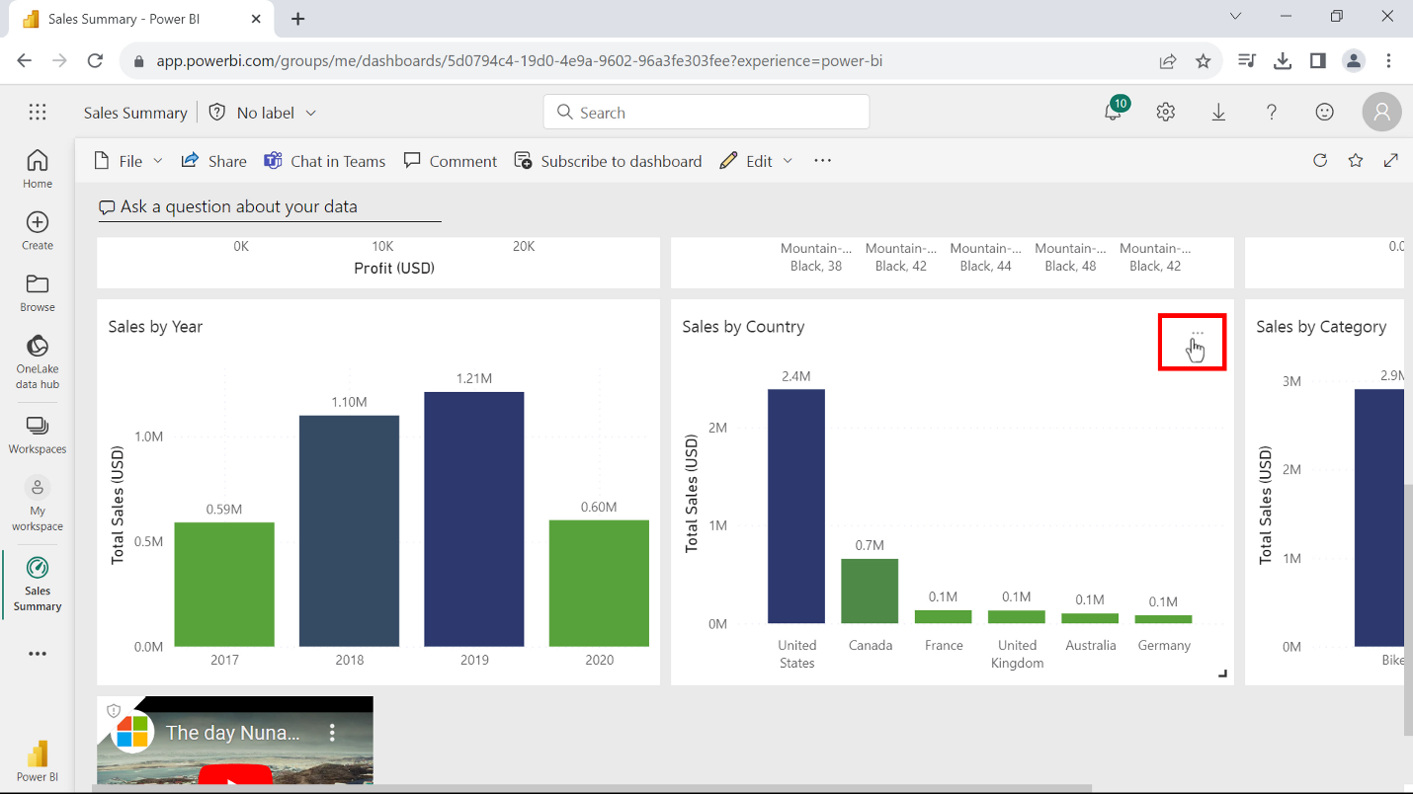

3. From the **More** **options** drop-down, select **Open in focus mode**. The visual displays full-screen in Power BI service.

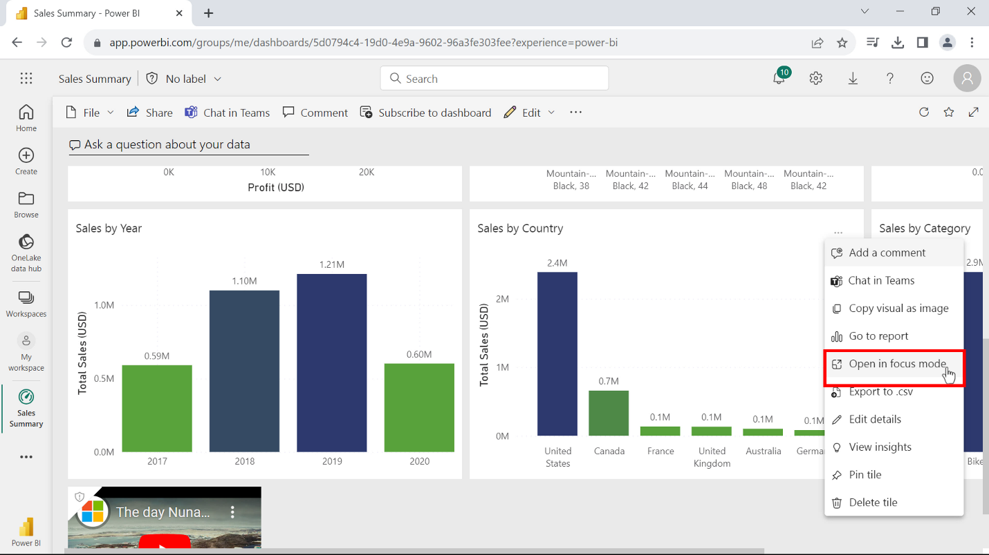

4. In the full-screen display of the **Sales by Country** visual, from the top right corner of its toolbar, select **More options,** and choose **Generate QR code** from the drop-down.

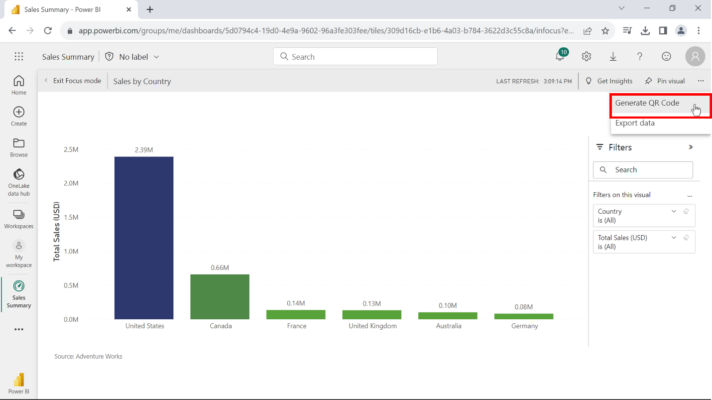

5. A dialog with the QR code appears. From here you can scan the code with your mobile device or download it to your local computer as a JPG file. The JPG file can be used for distribution as an email attachment or can be printed for physical display purposes.

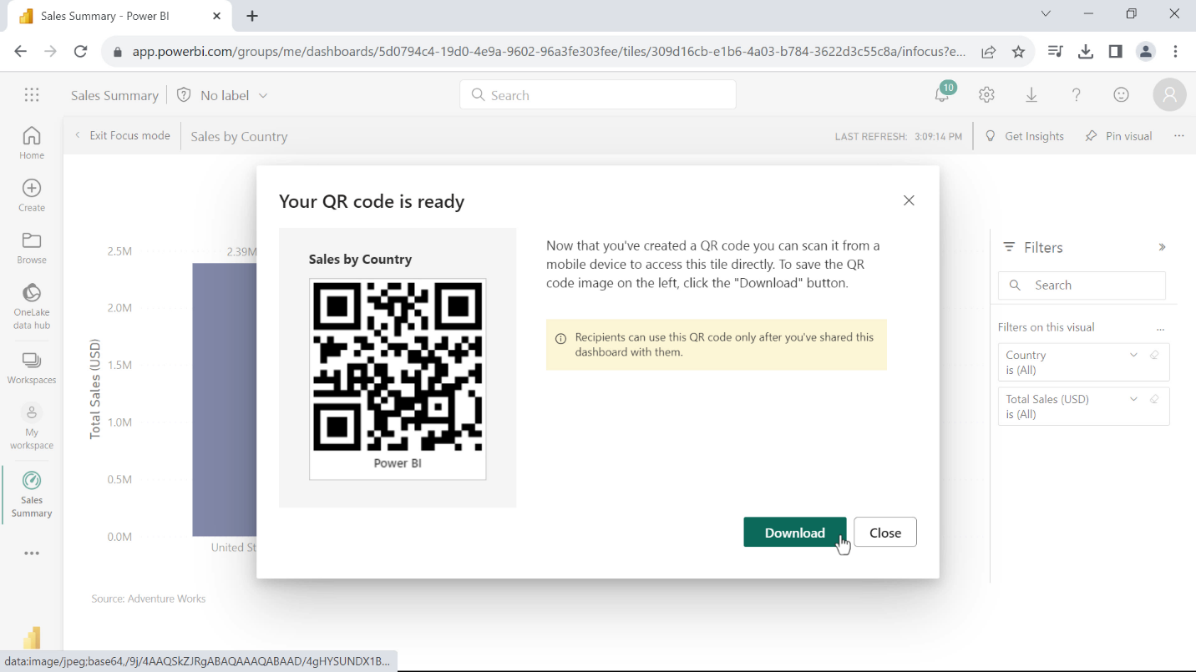

6. From the top left corner of the visual’s toolbar bar select **Exit focus mode,** to go back to the dashboard.

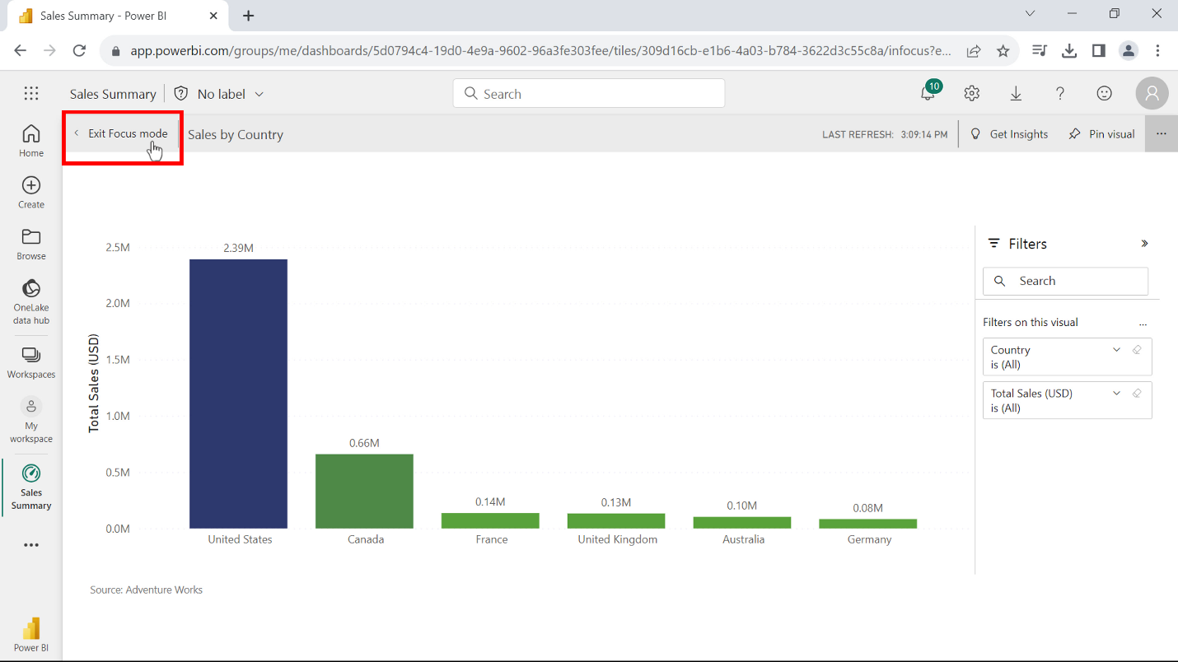

**Step 3: Open a report and create a QR code**

1. From the **My workspace** list of assets, open the **Adventure Works sales report**.

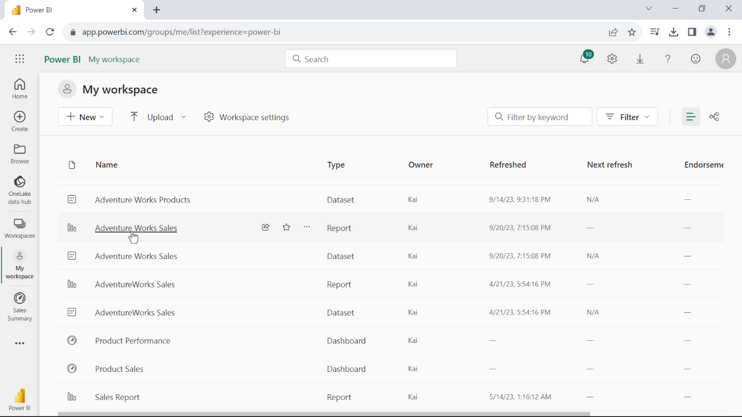

2. Select **File,** then select **Generate QR code**.

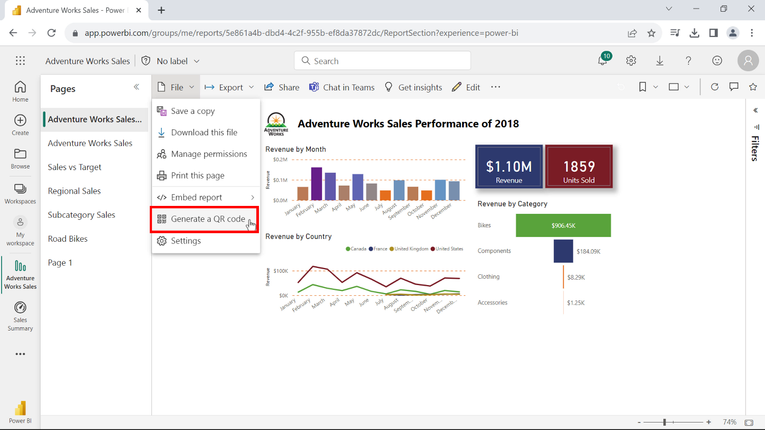

3. A dialog with the QR code appears. From here, you can scan the QR code and distribute it using your mobile device. You can also download the QR code as a JPG file for later use. Select **Close** to finish.

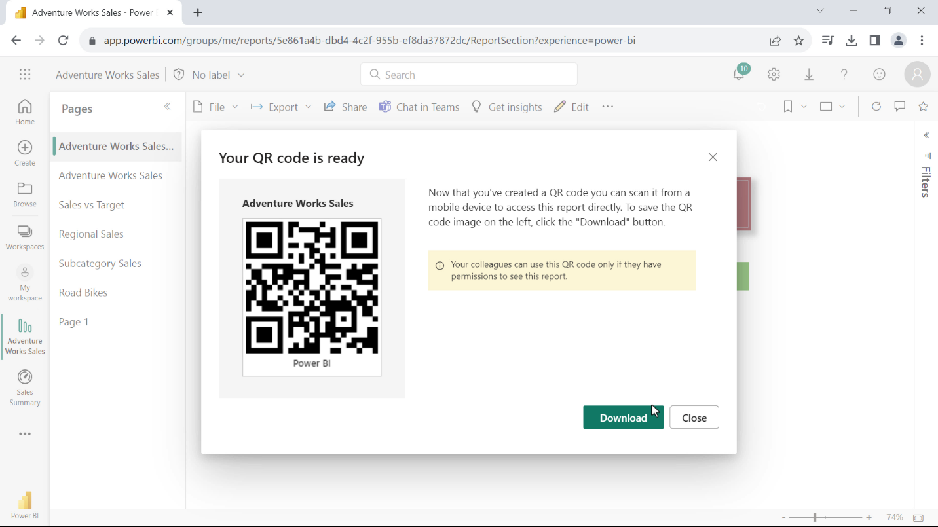

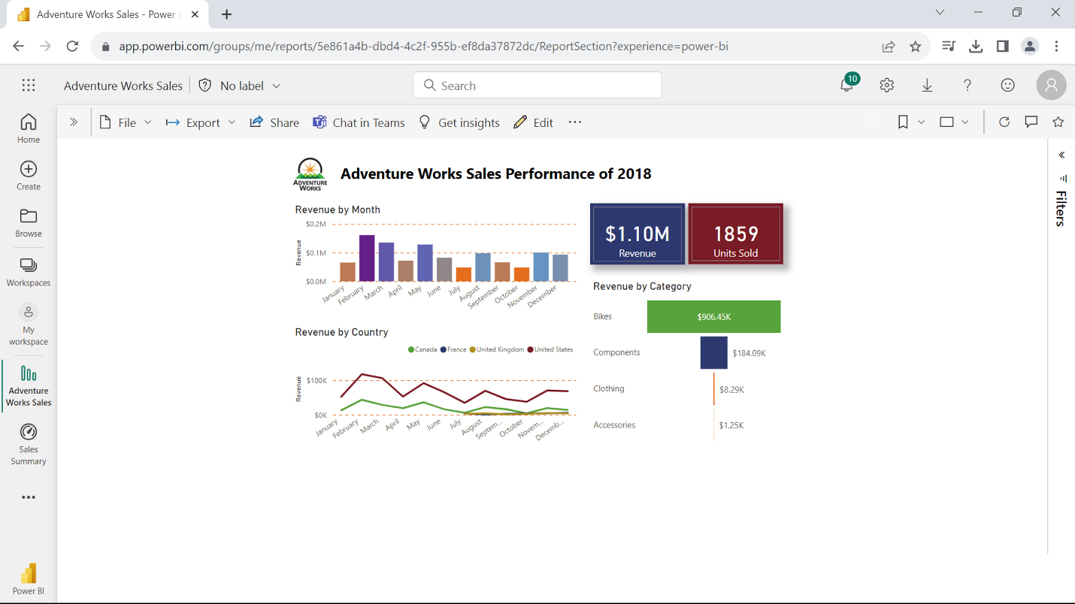

**Conclusion**

In this exercise, you generated QR codes that Jamie, the Adventure Works CEO, can now distribute to the sales managers in each region. These QR codes are to monitor sales data, but QR codes can be used to address a diverse range of applications. For instance, conducting surveys, collecting feedback, and providing additional context about the presented data.